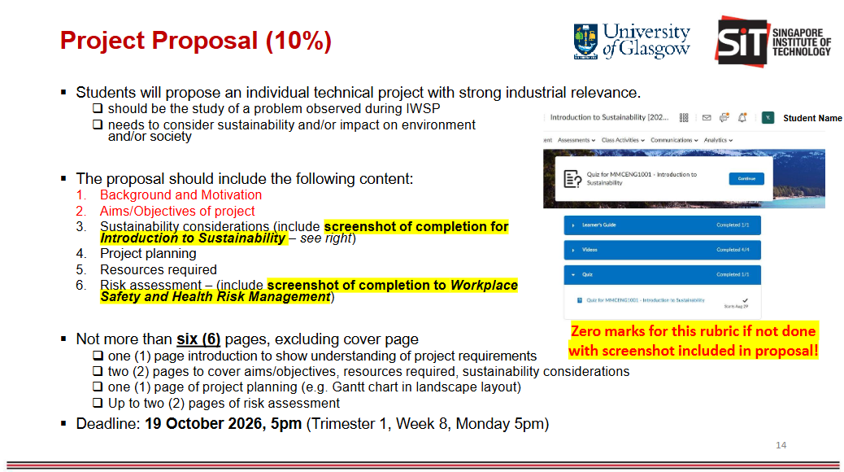

1. Background
Throughout the IWSP, the main project that I was embarking on was to build the N1 line. Although many of the prework was already done, such as the planning of the layout and the arrangement of the order of the processes, I could appreciate the the planning through the actual construction process of the established prework.

Prework:
The prework include PQPR, line balancing, SWS and SWCS, table-top simulation. The establishment of such prework helps to plan, validate and dictate the way the production line should be built and run.
Through my time in the IWSP workplace, I was also involved in **table-top simulation** to validate the layout and standard work of another production line. It was in that table-top simulation that brought to my awareness how much time is used in order to validate the standard workflow. While having an actual table-top simulation has it's benefits such as bringing the people who actually understands the process together, it is time consuming and much of the menial work can be processed by software first so that when an actual table-top is conducted, the tackling of issues would not be the validation of the flow but the accuracy and feasibility of the line creation.

Benefits of table-top simulation:
- Real-world validation: Operators can confirm whether the proposed sequence is actually practical, not just theoretically possible.
- Cross-functional input: Different stakeholders can immediately point out issues involving quality, tooling, maintenance, safety, production, or ergonomics.
- Identifies missing assumptions: For example, your software may assume an operator can immediately start the next process, while an operator might explain that they first need to collect a tool, inspect the part, complete documentation, or wait for equipment.
- Validates standard work: It allows the team to walk through each activity and confirm that the sequence, manpower assignment, and process responsibilities make sense.
- Improves communication: Everyone sees the same proposed workflow, reducing misunderstandings between engineering and operations.
- Captures human factors: Things such as awkward movements, accessibility, operator preference, visibility, communication between operators, and ergonomic concerns can be difficult to represent accurately in a simple simulation.
- Allows immediate discussion: When an issue is discovered, the group can propose and evaluate alternative arrangements together

As such, the capstone project is not to replace the table-top experience but to streamline it and pre-process the information. Its main purpose is to save time by pre-validating the standard work and keep the table-top simulation as a discussion to the feasibility of the line creation and its future operation. Hence, the table-top simulation will serve as a final validation before the plan is place into motion.

Motivation and Aim

Problem statement
How can production line workflows and standard work be efficiently validated while reducing the time and manpower required for conventional table-top simulations?

Project planning
Phase | Main Activities | Expected Output
1. Requirements & Problem Definition | Study current tabletop simulation process, identify user needs, define what the software must simulate | List of functional requirements
2. Data Collection | Gather process sequence, cycle times, operator movement, station layout, manpower and resource requirements | Input data for simulation
3. Simulation Design | Define simulation logic, data structure, workflow rules, and user interface | System architecture / flowchart
4. Software Development | Develop Python prototype, layout builder, workflow simulation, operator/resource logic and outputs | Working simulation prototype
5. Testing & Validation | Compare software results with an existing line or tabletop simulation | Validation results and identified gaps
6. Evaluation & Improvement | Refine the tool, assess usefulness, sustainability benefits and limitations | Final prototype and recommendations

